1.Get me the IP address of a particular domain (guvi.in).1.Get me the IP address of a particular domain (guvi.in). How do I find my CPU/memory usage of my server?. Test the connectivity between 2 nodes?

2.I have deployed an application in guvi.com:9000, and logs show my app is running, but I’m unable to view the page. Check whether my port is open or not ?

IP Address details:

Login to the server switch to root user and type “ nslookup guvi.in hit enter .

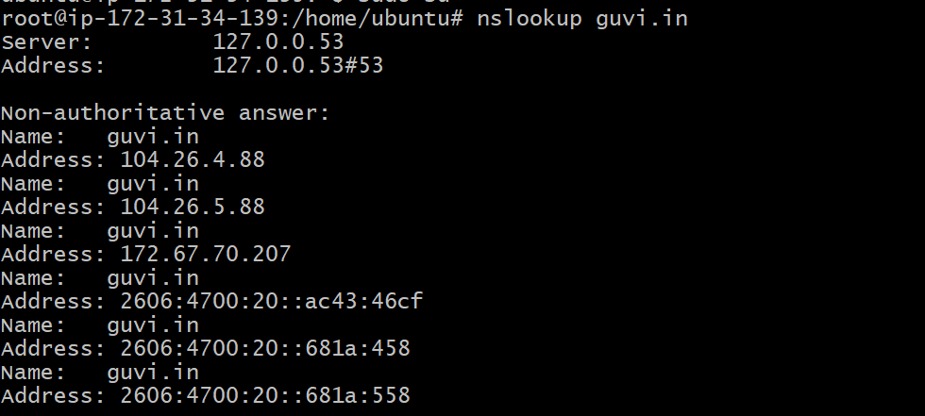

CPU/Memory usage of server :

Type “top “ command and hit enter .

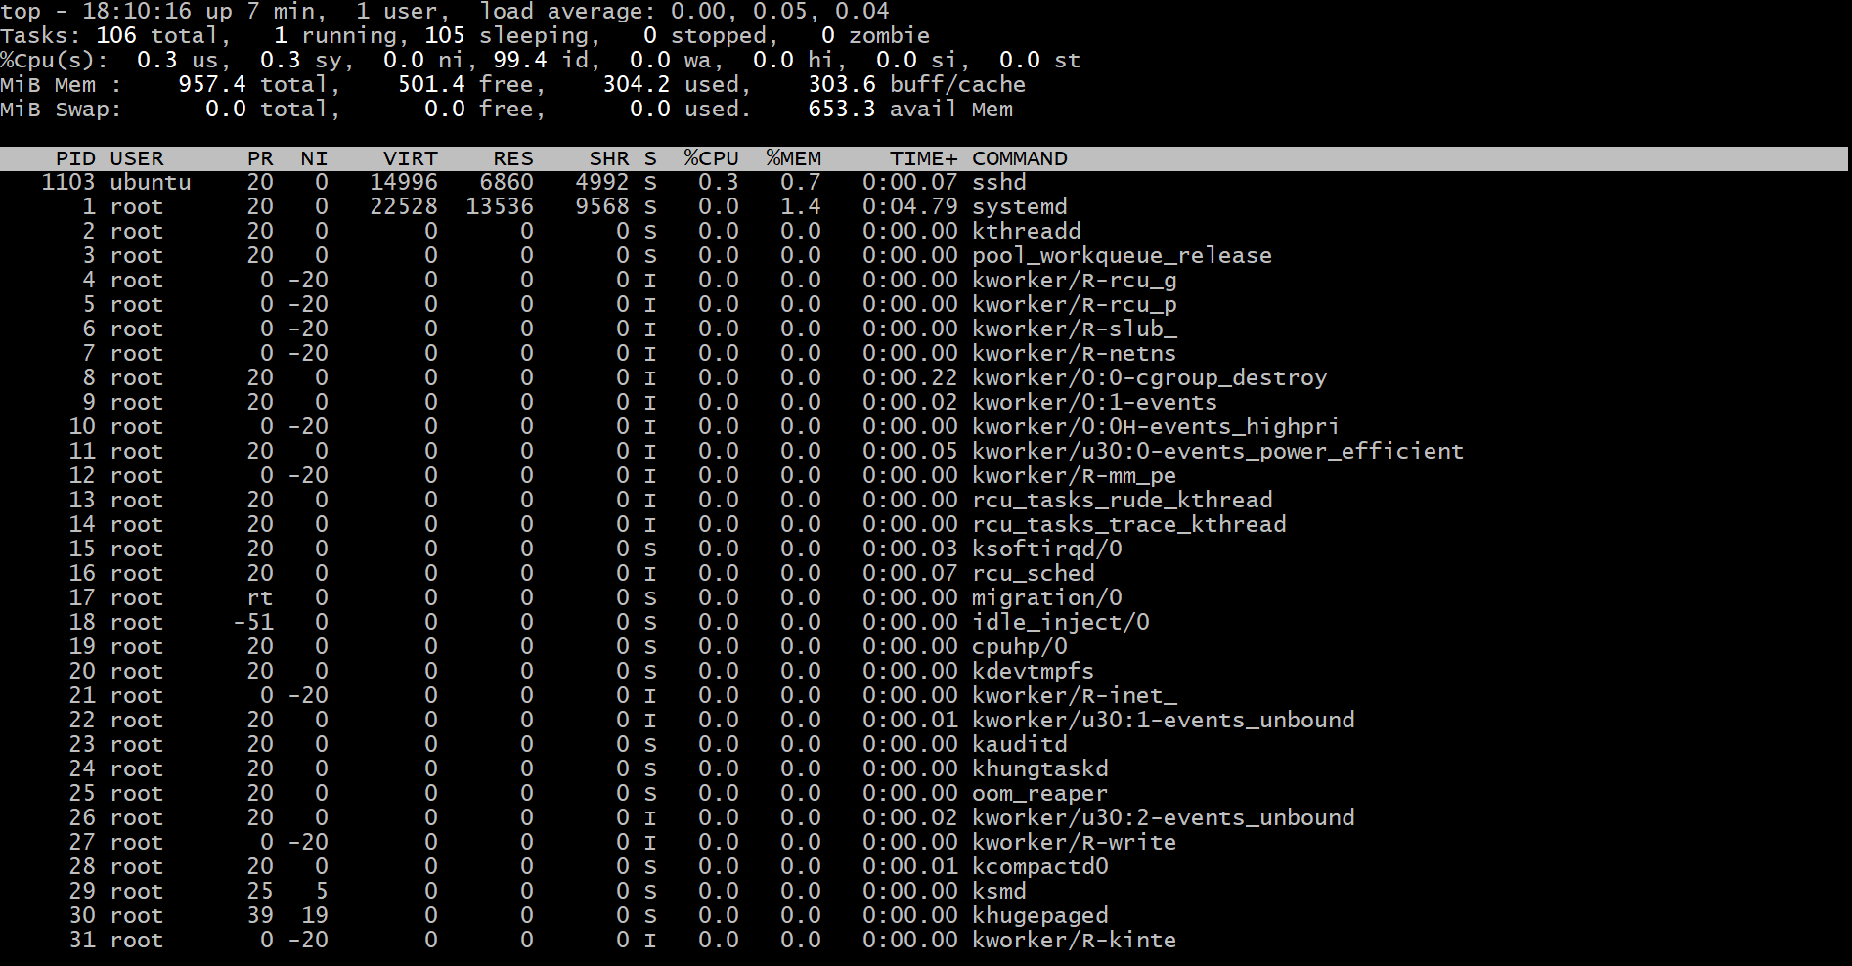

For Memoy:

Type “free -h” hit enter will get RAM information.

]

Test the connectivity between 2 nodes

Create 2 nodes in AWS

Node 1 IP 172.31.34..139



Node 2 IP 172.31.46.193



Login to the node1 and type telnet and private IP and port no. Hit enter .

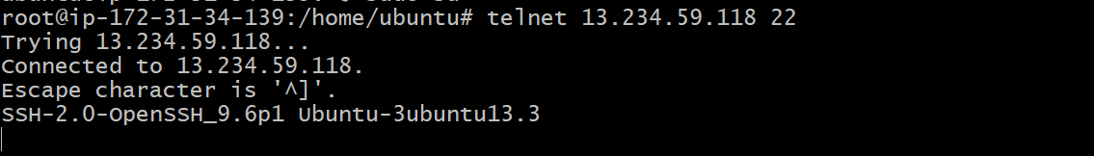

1. I have deployed an application in guvi.com:9000, and logs show my app is running, but I’m unable to view the page. Check whether my port is open or not ?

